###### Samples-XAI #####

show_gradcam("/content/drive/MyDrive/Samples-XAI/macules.jpg")

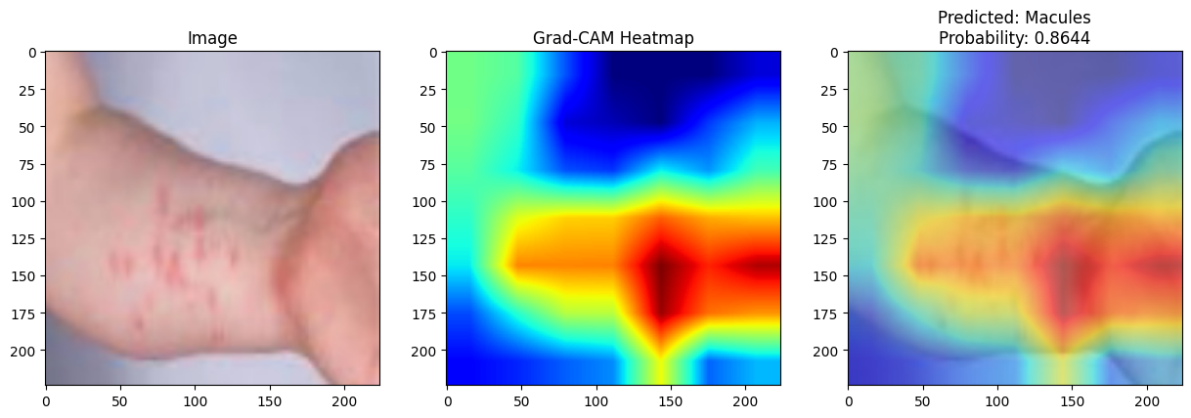

show_gradcam("/content/drive/MyDrive/Samples-XAI/Papules2.JPG")

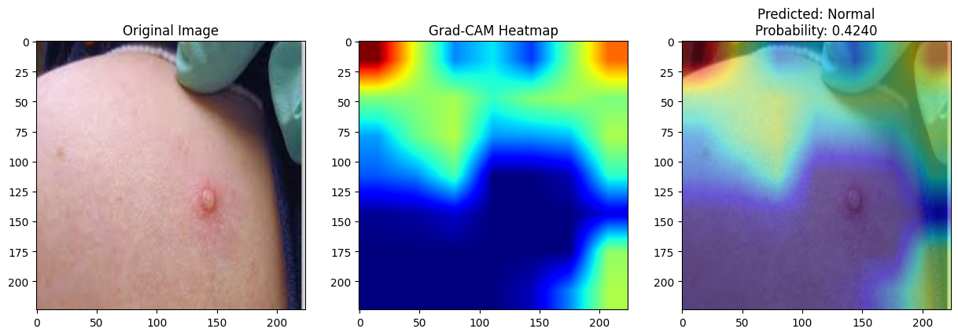
show_gradcam("/content/drive/MyDrive/Samples-XAI/Vesicles2.JPG")
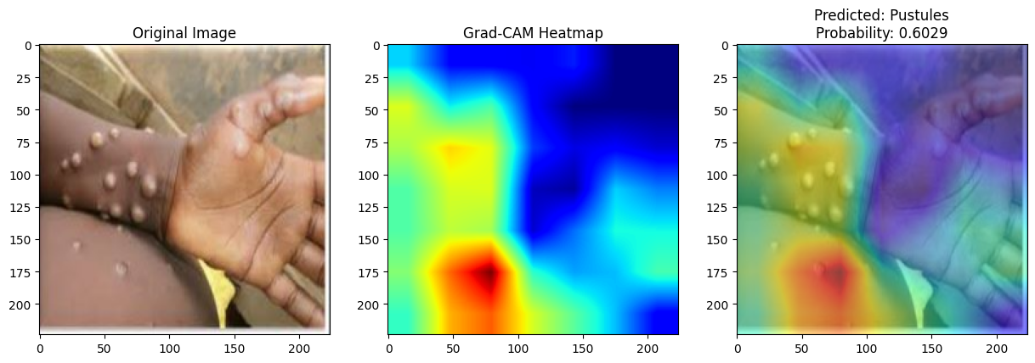

show_gradcam("/content/drive/MyDrive/Samples-XAI/pustules.JPG")
/usr/local/lib/python3.12/dist-packages/torch/nn/modules/module.py:1867: FutureWarning: Using a non-full backward hook when the forward contains multiple autograd Nodes is deprecated and will be removed in future versions. This hook will be missing some grad_input. Please use register_full_backward_hook to get the documented behavior.
self._maybe_warn_non_full_backward_hook(args, result, grad_fn)
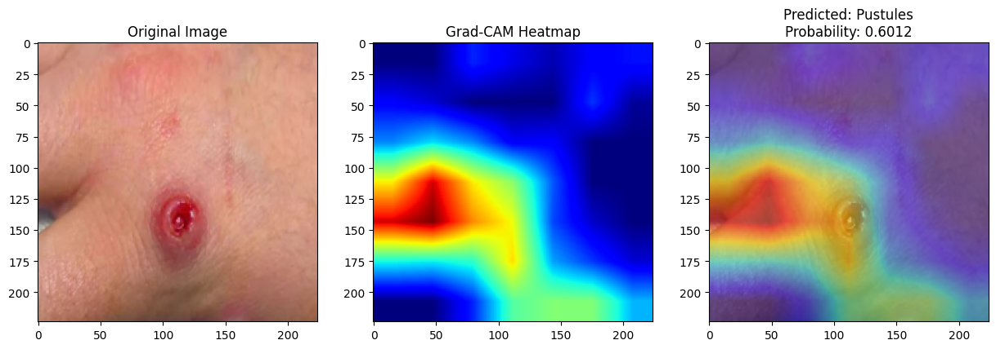

show_gradcam("/content/drive/MyDrive/Samples-XAI/scabs.jpg")
